

**Program: ESE 4009**

**INSTRUCTOR:** Prof**.** Mike Aleshams

# Group: Three

|  |  |  |
| --- | --- | --- |
| Student Name | Student ID | Signature* |
| JERIN JOY | C0755173 | JJ |
| KIRAN ANTO SEBASTIAN | C0753809 | KS |
| SHINU RAJ | C0749116 | SR |

*\*By signing above you attest that you have contributed to this submission and confirm that all work you have contributed to this submission is your own work. Any suspicion of copying or plagiarism in this work will result in an investigation of Academic Misconduct and may result in a “0” on the work, an “F” in the course, or possibly more severe penalties.*

**Project Proposal**

**Project Title:**

**IOT BASED SMART IRRIGATION SYSTEM USING BEGALBONE BLACK WIRELESS**

**Description of the latest similar system:**

The main feature of the smart irrigation system is to help the farmers keep track of the agricultural activities that is being held in the farm; each and every corner of the desired area. Existing systems use the Microcontroller ATMEGA328P on Arduino Uno platform or similar platforms, to implement the control unit.

It is also noted that most systems only use a single smart sprinkler that is controlled by weather and/or online data to determine when and how long to water the field. At that point, sprinklers apply simply enough water at precisely the correct time in each zone of your yard.

A smart irrigation unit uses micro controller based also has LED bulbs display boards. When the on-field sensors report that the moisture level has fallen below the recommended/threshold level, the bulb glows, indicating that an irrigation event has to be initiated (i.e. the sprinkler valves have to be turned on)

The day to day log about the activities done in the agricultural field can be updated. So we can have a system where the details of the daily activity is uploaded to the cloud.

**Limitations of the latest similar system:**

Like mentioned above the most of the system uses the Microcontroller on Arduino Uno. And we also know that an external Wi-Fi module is need when we uses the Audrino Uno.

Most of the system uses the one of the sensor that is either moisture sensor or humidity sensor. No data is made available weather data such as sunshine, temperature, and wind to help determine plant water requirements.

Pressure-regulating sprinklers: Manufactured sprinklers that regulate pressure to the nozzle over a range of inlet pressures.

**Final Solution:**

Proposed use of BeagleBone Black Wireless instead of microcontroller on Arduino board in accordance with the existing system. The system will comprise of a water pump system with the use of moisture sensor, temperature sensor and soil humidity sensor.

* **Block Diagram**

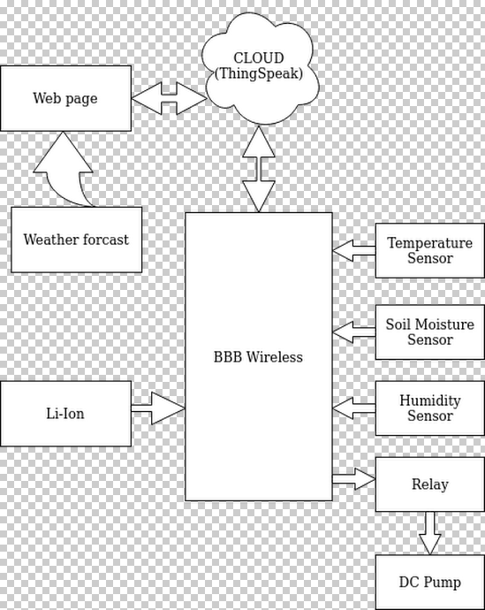

* **Features**
* The project makes use of peripherals such as temperature sensor, moisture sensor, humidity sensor, water pump system
* Communication channels and/or platforms include UART, IEEE 802.11 Wi-Fi (BBB onboard 802.11 b/g/n 2.4 GHz Wi-Fi)
* Preemptive; Round Robin with interrupt architecture proposed with fixed time slicing between tasks.
* Priorities of the tasks are fixed and with weather forecasting data interpretation occupying the top of the stack
* Power management is established by making use of the data from weather forecast to suspend irrigation system in the instance of rain; Sensors will also remain in an idle state and resume at fixed intervals.
* **Hardware and Software Requirement**

**Hardware**

1. BeagleBone Black Wireless
2. Temperature sensor
3. Soil Moisture sensor
4. Humidity sensor
5. Dc pump System
6. Lithium Ion battery

**Software**

* + - 1. Linux operating system
      2. Programming Language: C, Python(library files for Sensors)
      3. WordPress
      4. Eclipse
      5. Thingspeak
      6. Open weather map API
      7. EasyEDA
* **References:**

Laura Garcia (2020, 14 February) *IoT- Based smart irrigation system*, Retrieved from <https://www.mdpi.com/1424-8220/20/4/1042/htm>

Abhiemanyu Pandit (2019, 15 July) [*IoT based Smart Irrigation System using Soil Moisture Sensor and ESP8266 NodeMCU*](https://circuitdigest.com/microcontroller-projects/iot-based-smart-irrigation-system-using-esp8266-and-soil-moisture-sensor), Retrieved from<https://circuitdigest.com/microcontroller-projects/iot-based-smart-irrigation-system-using-esp8266-and-soil-moisture-sensor>

International Journal of Computer Applications (2017, 11 February) *IoT- Based smart irrigation system*, Retrieved from<https://www.researchgate.net/publication/313779760_IOT_based_Smart_Irrigation_System>

**Milestone:**

|  |  |  |  |  |
| --- | --- | --- | --- | --- |
| **SNO.** | **TASK** | **STARTING DATE** | **ENDING DATE** | **INCHARGE** |
| 1. | Hardware selection and acquisition | **June 17,2020** | **June 29,2020** | **Jerin Joy** |
| 2. | Design hardware schematics | **June 29,2020** | **July 6, 2020** | **Shinu Raj** |
| 3. | BBB Debian flashing, preliminary open coding, BBB hibernation | **July 8, 2020** | **July 13, 2020** | **Kiran Anto Sebastian** |
| 4. | Interfacing with open weather map API | **July 14, 2020** | **July 20, 2020** | **Jerin Joy** |
| 5. | Moisture sensor integration | **July 21, 2020** | **July 27, 2020** | **Shinu Raj** |
| 6. | Temperature and humidity sensor integration | **July 29, 2020** | **August 05. 2020** | **Kiran Anto Sebastian** |
| 7. | Establishing cloud connectivity | **August 06. 2020** | **August 13. 2020** | **Jerin Joy** |
| 8. | Webpage development | **August 14. 2020** | **August 21. 2020** | **Shinu Raj** |
| 9. | Hardware assembly; onboard software testing; deployment and testing | **August 21. 2020** | **August 28. 2020** | **Kiran Anto Sebastian** |

**Instructor’s Remarks:**